1.
List 5 common BIOS or POST error messages you might see when starting a PC and write what hardware or configuration issue each one usually points to.
Error Messages | Hardware or configuration issue
CMOS Battery Low | Dead/missing CMOS battery causing loss of BIOS settings.
CMOS Checksum Error – Defaults Loaded | Corrupted BIOS settings
Keyboard Error or No Keyboard Present | Keyboard not connected
No Boot Device Found | HDD/SSD not detected
CPU Fan Error | Fan not spinning or risk of overheating.

2.
Given this scenario: On boot, a PC beeps 3 times in a repeating pattern and does not display anything on the screen. Research and write what this POST beep code typically means for an AMI BIOS, and suggest two troubleshooting steps.
The BIOS detects faulty or improperly seated memory.
Troubleshooting Steps:
Reset RAM modules - power off, remove, and reinstall RAM
Clean the RAM module – clean the dust from module and reinstall the RAM

3.
Access the BIOS setup utility on any available PC or virtual machine, take a screenshot of the main BIOS screen, and identify the motherboard manufacturer and BIOS version.
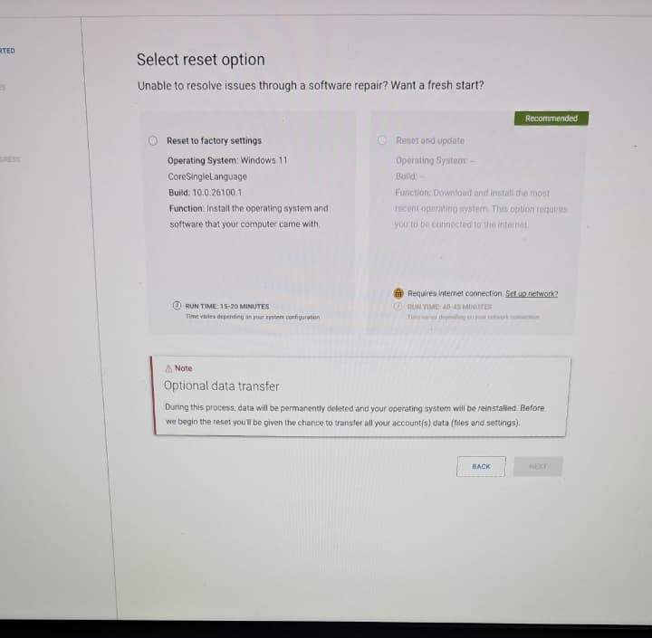
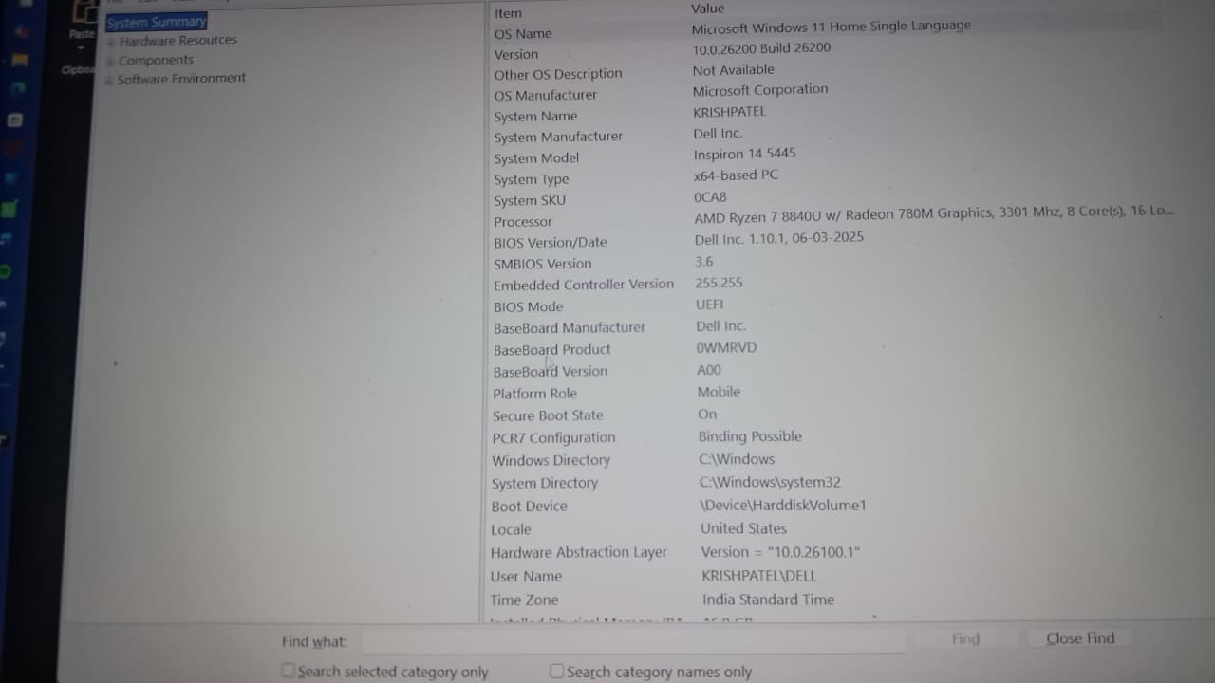

4.
You are given a screenshot of a POST error message that says 'CMOS checksum error – Defaults loaded.' Explain what this means and describe how you would resolve this issue in a real system.<br><br><em><strong>Hint:</strong> Think about the CMOS battery and BIOS settings reset.</em>

The BIOS detected corrupted or mismatched CMOS data. This usually happens when the it is weak or dead.
Resolution Steps:
- Replace CMOS battery — power off, remove the old battery, and insert a new one.
- Enter BIOS Setup — load Optimized Defaults or manually reconfigure settings (date, time, boot order).
- Save & Exit — system should boot normally with stable settings.

